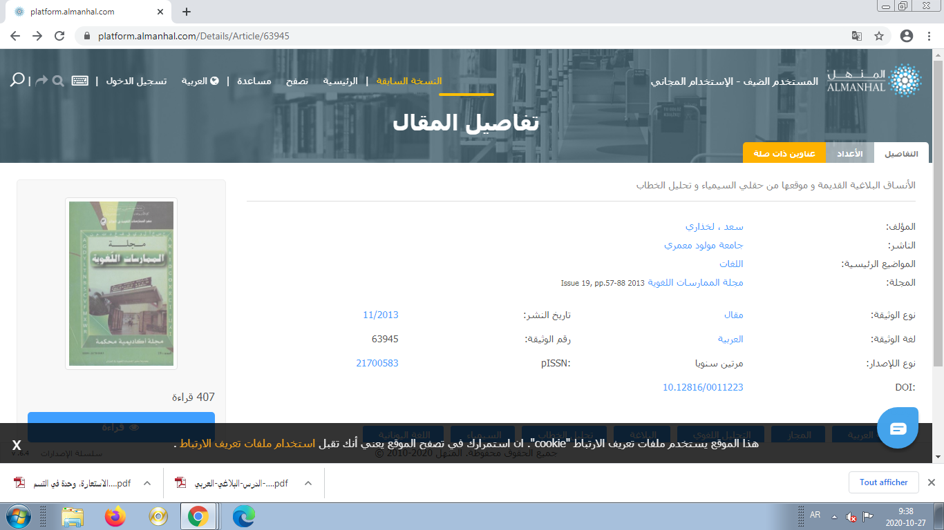

Article Details - platform.almanhal.com
platform.almanhal.com › Details › Ar...

· Translate this page
سعد ، لخذاري. Publisher: Mouloud Mammeri University. Main Topics: LANGUAGES. Journal: Majallat al-Mumārasāt al-Lughawīyah 2013 Issue 19, pp.57-88.
by سعد، لخذاري · ‎2013 · ‎Related articles

